STP Interview Prep
STAR METHOD
Situation
Task
Action
Result
What's the scope of a clinical scientist?
Clinical scientists can't prescribe or initiate treatments but they can aid and support diagnose and suggest treatments that could be performed based on current guidelines. They aim to support clinicians rather than replace them
Anaemias
Microcytic anaemias

Thalassemia's and anaemia
Structure of haemoglobin:
Quarternary structure containing four polypeptides. Two alpha chains and two beta chains (In adults). Each subunit has a heme group and each haem group accomodates an iron Fe2+ atom which attracts one oxygen molecule. Therefore, each haemoglobin molecule has 4 haem groups and can accomodate four oxygen molecules.
Depending on whether the haemoglobin molecule is bound to oxygen or not leads to confirmational shifts that either promote uptake of oxygen (e.g. in lungs) or encourage release of oxygen (hypoxic conditions e.g. organs needing oxygen)

When lots of oxygen is present in the tissue the structure remains tense holding onto the o2 molecules but when the concdnetration of co2 is higher the bonds break encouraging the release of o2.
Subunit types:
Although in adults there tends to be alpha and beta chains there are two other types of chains including gamma and delta chains
In the foetus babies don't have beta chains but have predominantly gamma chains. HbF therefore comprises of two alpha chains and two gamma chains. The gamma chains have a higher affinity for oxygen and therefore allow the baby to pull oxygen molecules across the placenta.
HbA2
Unlike HbA and HbF, HbA2 consists of two alpha chains and two delta chains. It counds for around 2% of all adult haemoglobin. More importantly, a raised A2 >3.5% is diagnostic of a beta thalassaemia. This is because the body compensates by increasing the % of haemoglobin A2 made.
A low level of HbA2 can indicate iron deficiency.
Laboratory overview suggestive of thalassemia
FBC:
Hb ⬇
MCV ⬇
MCH ⬇
MCHC ⬇
Features of alpha thalassaemia:
Severity depends on how severe the deficiency is
1 or two gene alterations/deletion is minor
3 deletions or alteration = HbH disease. This extra peak is formed due to the excess beta chains present.
4 deletions or alterations = hydrops fetalis

First early peak on this graph shows HBH and would be seen on HPLC chromatograph.

Features of Beta thalassemia:
1 gene deletion/alteration = minor beta thalassaemia shown in lab results as an A2 >3.5%
Will be slightly anaemic but not severe
2 gene deletion = beta thalassaemia. Lab results will show no or trace HbA production, 90-95% HbF peak and a raised HbA2.
Severe anaemia requiring chronic transfusion support.

Clinical categorisation:
thal trait = mild reduction in hb and just need to ensure patient doesn't have excess iron to cause iron overload
thal intermedia = often patients don't reuqire transfusion but during stress or combined with other clinical issues may need ocassional transfusion.
beta major and other more serious thalassaemia = require lifelng transfusion support.
Iron deficiency anaemia
Iron deficiency anaemia can be caused by:
Chronic blood loss e.g. heavy periods, GI bleeding or the chronic use of NSAIDs which can cause stomach bleeding.
Reduced dietary intake of iron
Increased dietary need for iron e.g. pregnancy, growthspurts in teenagers
Maladsorption of iron into the gut e.g. coeliac disease where eating gluten causes antibodies to attack the lining of the gut leading to vili damage leading to maladsorption of nutrients into the gut
Megaloblastic anaemias
Megaloblastic anaemias have a variety of different causes. The main cause of megaloblastic anaemias are nutritional deficiencies in B12 or folate.
Deficiencies in B12 can occur due to:
- Reduced dietary intake e.g. strict vegetarianas
- Maladsortion of B12 due to Crohn's disease
- Perinicious anaemia - This is an autoimmune condition where antibodies attack the stomach cells which produce intrinsic factor. Intrinsic factor is essential for B12 uptake
- Gastrosurgery - Where parts of the stomach are removed e.g. due to cancer and this prevents uptake of B12
- Parasitic infections - Some parasitic infections such as tapeworm steal the B12 preventing uptake in the GI tract.
Deficiencies in folate can occur due to:
- Reduced dietary intake of folate
- When there's increased demand for folate e.g. during prenancy or from chronic haemolytic anaemia.
- Like iron deficiency coeliac disease can cause folate deficiency. Crohn's disease more affects B12 levels.
Blood film findings for B12 folate deficiencies:
- Polychromasia
- Macrocytes
- Anisopokilocytosis
- Hypersegmented neutrophils (5 or more lobes)

Drug induced haemolytic anaemia
Another example of a megaloblastic anaemia is drug induced haemolytic anaemia. This is a rare but serious condition that occurs when drugs covalently bind to the Rbc and immune antibodies then bind to the drug marking the red cells for destruction
Examples of drugs that have been associated with DIHA include:
- NSAIDs
- Cephalosporins
- Penicillins
The main way to treat drug induced haemolyic anaemia is to stop the drug which is triggering the drug induced haemolytic anaemia.

Normocytic anaemia causes
Normocytic anaemia can have a wide range of causes including but not limited to:
Blood loss
Infections e.g. malaria
G6PD deficiency
Hereditary spherocytosis
AutoImmune haemolytic anaemia
Haemolytic transfusion reaction
Kidney disease
Mixed nutritional deficiencies

Transfusion reactions
Immune transfusion reactions
Immune transfusion reactions can be classified into two main types including:
- Acute haemolytic transfusion reaction (AHTR)
Generally caused by IgM antibodies e.g. ABO antibodies due to ABO incompatible transfusion.
Causes intravascular haemolysis due to rapid complement activation. This causes the formation of attack membrane complex causing red cell haemolysis. This causes the release of free haemoglobin into the plasma causing hyperbilirubinaemaia.
AHTR causes an increase in bilirubin, LDH and haemoglobinaemia (markers of haemolysis) and decreased haptoglobin.
Symptoms are severe and occur within 24hrs of transfusion e.g. haemoglobinuria, hypotension, SOB, fever, chills
AHTR is mainly caused by WBIT.
(Haptoglobin is a protein which binds to free haemoglobin in the plasma and allows processing by the liver to retrieve iron)
- Delayed haemolytic transfusion reaction (DHTR)
DHTRs generally cause extravascular haemolysis where cells marked with antibodies are removed by the spleen and liver by macrophages.
DHTR's are generally caused by IgG antibodies e.g. Anti-K binding to a K+ erythrocyte as part of an amanestic response
Symtp
(Amanestic response means the rapid production of antibodies are previously being stimulated by a foreign antigen. These antibodies also have a higher affinity than previous antibodies).
Non-immune transfusion reactions
Transfusion associated circulatory overload (TACO) - This is where the volume of transfused product overhwhelms the circulatory system. This causes fluid to leak into the lungs (cardiogenic pulmonary oedema) which causes respiratory distress. This is a leading cause of transfusion related morbidity and is underdiagnosed. Elderly patients, children and neonates or those with cardiovascular/kidney problems are at a higher risk of TACO.
Patients with TACO epxerience respiratory distress, hypertension ,tachcycardia and cyanosis. Cyanosis within 12 hours of transfusion is an early diagnostic indicator of TACO.
Transfusion associated acute lung injury (TRALI) - Unlike TACO which causes pulmonary oedema due to circulatory overload, TRALI is believed to occur due to donor HLA antibodies in the plasma of the blood components or plasma components which react against the recipients ehite blood cells.
In Trali, the donor HLA antibodies in the blood component cause granulocyte activation and the release of cytokines causing further granulocyte recruitment and inflammatio cytokine release. This causes the vasculature of the lungs to become more permeable causign non-cardiogenic pulomary oedema.
Laboratory findings for TACO and TRALI:
- TACO ⬆BNP and hypertension
- TRALI Normal BNP and normotensive
BNP (B-TYPE NATRUIETIC PEPTIDE shows signs of cardiac stress)
Febrile non haemolytic transfusion reaction (FNHTR)
Febrile non-haemolytic transfusion reaction occurs due to cytokines stored within the blood components themselves due to the presence of WBC's. The main cytokine believed to be in play is interleukin-1 (IL-1).
When transfused to the patient this causes the patient to develop fever, chills and rigor. It's treated by stopping the transfusion and giving anti-pyretics.
Febrile non-haemolytic transfusion reactions are one of the most common causes of transfusion reaction. We aim to prevent them by leukoreducing blood components.
Allergic Transfusion reactions
The last major type of transfusion reaction are allergic transfusion reactions.
This reactions occur in patients who are severely IgA deficient. When a patient receives a donation from a patient with anti-IgA, the anti-IgA is marked by the mast cells with anti-IgE which binds to the donors anti-igA antibodies and degranulate releasing histamine and causing an allergic reaction.
The symptoms of allergic transfusion reactions include:
- Urticaria - rashes
- Hypotension
- tachycardia
Laboratory findings for allergic transfusion:
- Negative DAT
- Normal LDH, bilirubin, haptoglobin
- IgA deficient
Initial treatment of allergic transfusion reactions include epinephrine and then respiratory support if the patient requires it.
Major haemorrhage protocols
A major haemorrhage is a rapid coordinated response to bleeding when there is a risk to life. This ensures timely delivery of blood products to support haemostasis. Major haemorrhages have to have a rapid coordinated response to improve patient outcomes.
Major haemorrhages often present with tachycardia, falling hb and hypotension.
Within major haemorrhage protocols there is something key to be aware of known as the 'deadly triad'.
The deadly triad consists of three main components including:
- Hypothermia
- Acidosis
- Coagulopathy

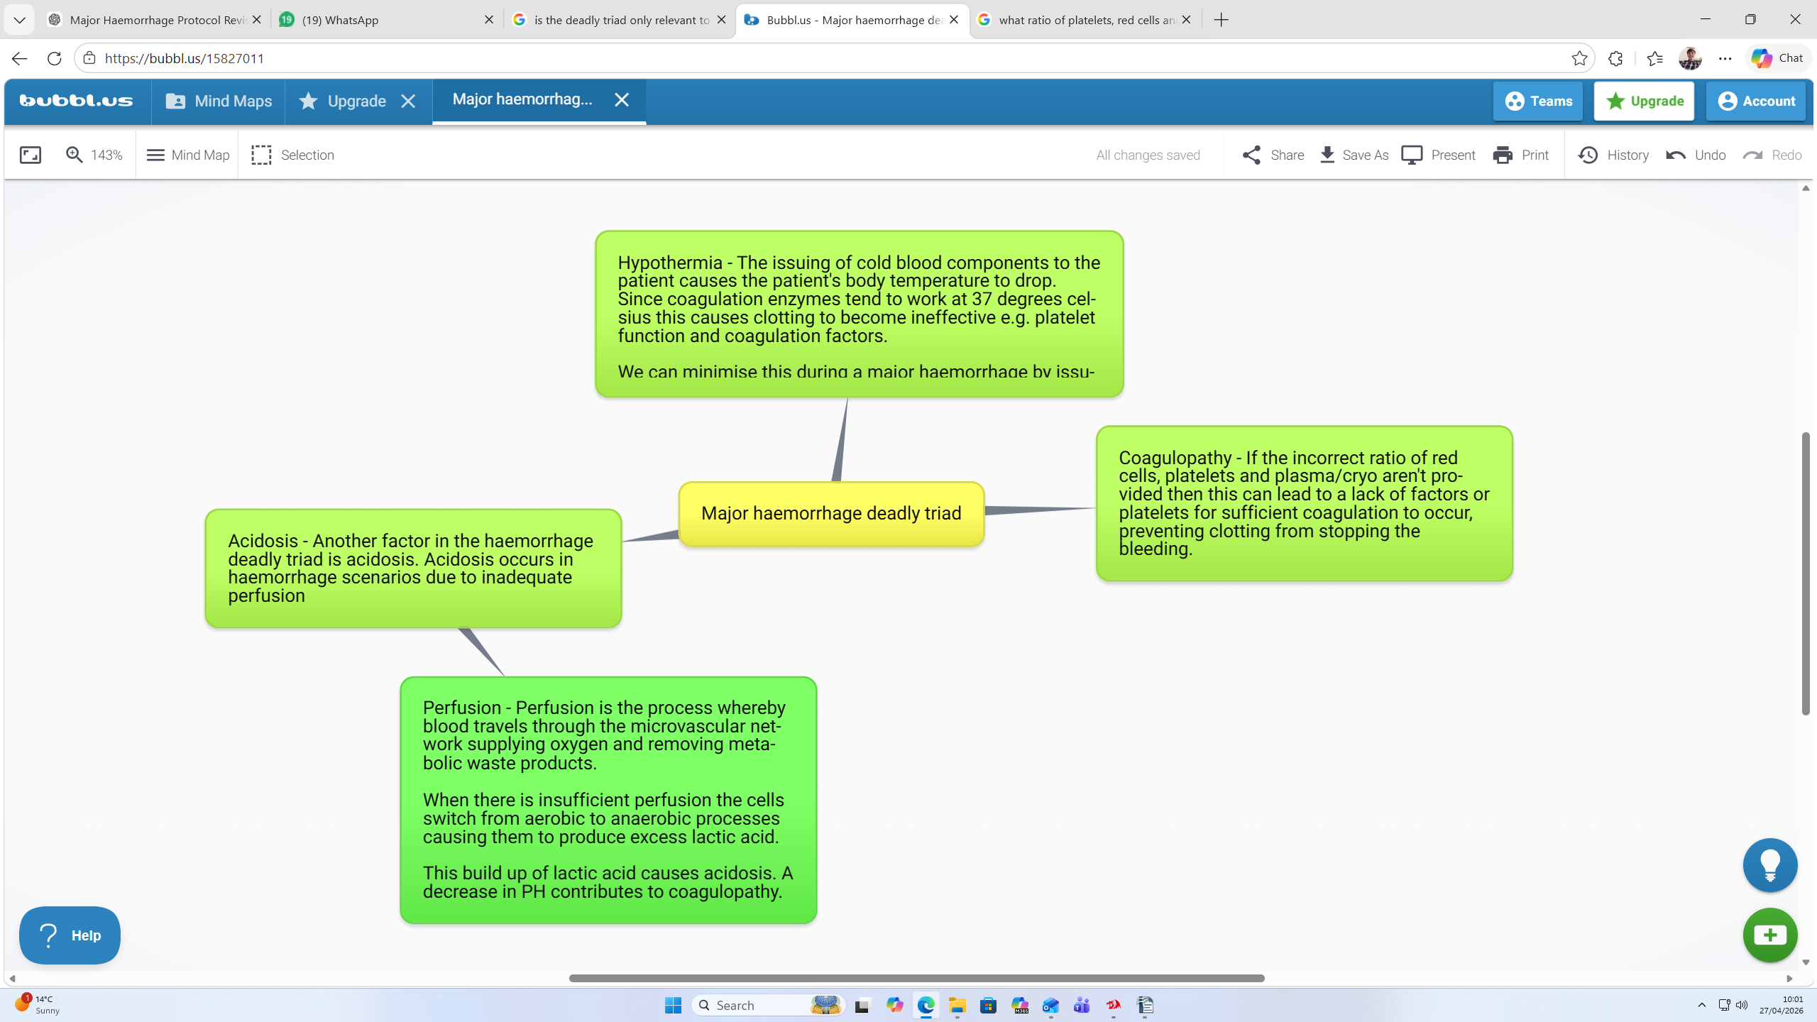
Major haemorrhage protocols and specialised pathways
Most hospitals have one main major haemorhhage protocol and then this protocol is adapted for other specialised pathways.
In order to prevent coagulopathy the recommended ratio of red cells, plasma, platelets is often 1:1:1. This ensures there are enough red cells, clotting factors and platelets to ensure haemostasis.
However, in an obstetric haemorrhage the difference is that more emphasis is placed on giving fibrinogen early, as pregnancy can lead to hypercoagulable states. This is because prior to childbirth the levels of coagulation factors, fibrinogen etc rapidly promote clotting as bleeding is an expected outcome of childbirth, therefore when massive bleeding occurs in obstetric haemorrhages fibrinogen can be depleted very rapidly. For this reason fibrinogen is given earlier in obstetric haemorrhages especialy if fibrinogen was <2.0g/l to prevent DIC and maintain haemostasis.
Also during pregnancy there are decreased levels of the anticoagulants protein C and protein S.
Example of haemorrhage packs:
Adult Trauma:
Major haemorrhage protocols start with a primary pack or pack A.
Pack A:
- 4 units red cells
- 4 units of FFP
Pack B:
- 4 units red cells
- 4 units FFP
- 1 unit of platelets

Pack C:
4 red cells
1 FFP
1 Platelet
2 x cryoprecipitate

Obstetric Haemorrhage
The key difference between an adult trauma pack and an obstetric haemorrhage pack is that cryo is given earlier due to the rapid fibrinogen depletion that occurs in obstetric haemorrhages.

Pack A
- 4 red cells
- 4 FFP
(Same as in a trauma pack)
Pack B
- 4 red cells
- 4 FFP
- 2 cryoprecipitate
Pack C
4 Red cells
1 plasma
1 platelet
more cyro if required.
Other medications used to improve patient outcomes:
Critically when there is a high risk of bleeding transexamic acid can also be used. Tranexamic acid reduces bleeding during surgeries or haemorrhages as it prevents fibrinolysis.Tran examic acid prevents the conversion of plasminogen to plasmin which is the enzyme responsible for breaking down fibrin clots.

